# Homework: Entity Framework Code First

This document defines the homework assignments from the ["Database Applications" Course @ Software University](https://softuni.bg/trainings/21/Database-Applications-Mar-2015). Please submit as homework a single zip / rar / 7z archive holding the solutions (source code) of all below described problems.

## Code First Student System

Your task is to create a database for the **Student System**, using the **Entity Framework Code First** approach. Model the following tables:

* **Students**: id, name, phone number (optional), registration date, birthday (optional)
* **Courses**: id, name, description (optional), start date, end date, price
* **Resources**: id, name, type of resource (video / presentation / document / other), URL
* **Homework**: id, content, content-type (e.g. application/pdf or application/zip), submission date

Table relations:

* **Students** can be in **many course**s
* **Courses** can have **many students**
* **Courses** can have **many resources**
* **One course** can have **many homework submissions**
* **Homework submissions** have a **student**

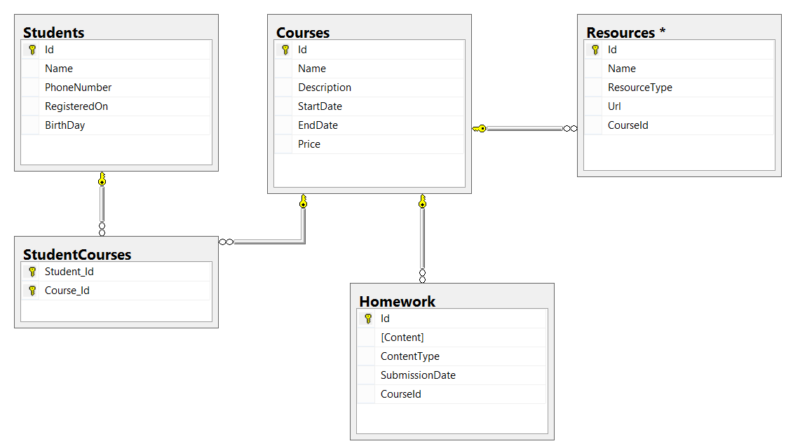

Add **navigational properties** in all models to simplify navigation. Annotate the data models with the appropriate **attributes** and validations and **enable code first migrations**.

Separate the **models**, **data** and **client** into **different layers** (projects).

## Seed Some Data in the Database

Write a **seed method** that fills the database with sample data (randomly generated).

Fill a few **students**, **courses**, **resources** and **homework submissions**. Configure Entity Framework to run the **Seed()** method after the database is created for the first time (i.e. only if it's empty).

Run the application several times to ensure that it seeds sample data **only** **once**.

## Working with the Database

Write a console application that works with the EF data layer and performs the following CRUD operations:

1. Lists **all students** and their **homework submissions**. Select only their **names** and for each homework - **content** and **content-type**.
2. List **all courses** with their corresponding **resources**. Select the **course name** and **description** and everything for each **resource**. Order the courses by start date (ascending), then by end date (descending).
3. List **all courses** with **more than 5 resources**. Order them by **resources count** (descending), then by **start date** (descending). Select only the **course name** and the **resource count**.
4. List all courses which were active on a given date (choose the date depending on the data seeded to ensure there are results), and for each course count the number of students enrolled. Select the course name, start and end date, course duration (difference between end and start date) and number of students enrolled. Order the results by the number of students enrolled (in descending order), then by duration (descending).
5. For each student, calculate the number of courses she’s enrolled in, the total price of these courses and the average price per course for the student. Select the student name, number of courses, total price and average price. Order the results by total price (descending), then by number of courses (descending) and then by the student’s name (ascending).

## Resource Licenses

Resources should now have many **licenses**. A **license** should have an **Id** and **Name**.

Make these changes using Code First Migrations. Make sure no data is lost after the update.